Supplemental Material for

Ghost, Divination, and Magic among the Yi:

An Ethnographic Examination from Cognitive and Cultural Evolutionary Perspectives

1a) Detailed descriptions of sheep shoulder blade bone divination (*yopiji*):

A full description of sheep shoulder blade bone divination can be found in Hong & Henrich (2021) for contemporary Yi in Liangshan. See Zhang (1994) and Lin (1964) for very similar types of sheep shoulder blade bone divination in Yunnan province. Additional pictures are shown in SM Figure 1. SM Video 2 shows how it is used in practice.

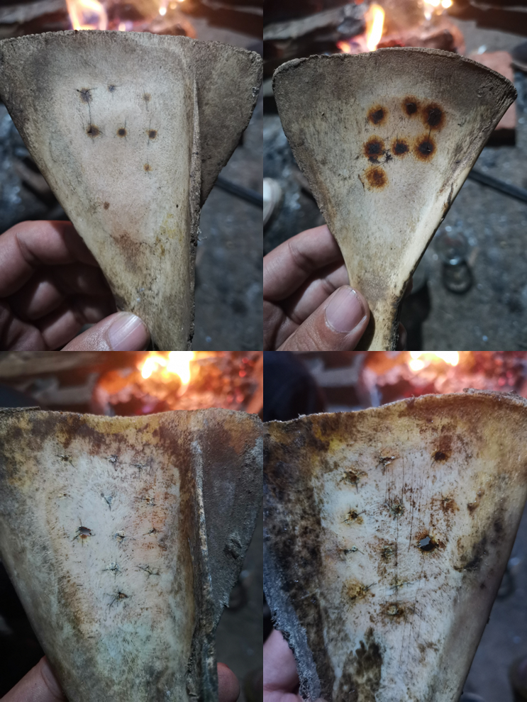

SM Figure 1. The front and back side of two different sheep shoulder blade bones.

1b) Detailed descriptions of Artemisia twigs divination (*saiyomo*):

Like sheep shoulder blade bone divination, this type of twig divination is usually used to determine whether a particular action should be performed. The divination specialist (not necessarily a *bimo* or *suni)* would chant as he/she carves small marks of roughly equal spacing (2-3 centimeters) along an Artemisia twig from one end to the other. When the carving is done, he/she “randomly” makes two additional marks on the twig and divides it into three parts. He/she then checks the parity of the number of carved marks on the three twig parts pronounced whether the sign is auspicious or inauspicious (Zhang, 1994). See SM video 4 and 5 for how it’s used in practice.

2) Full description of a traditional healing ritual (exorcism):

Depending on the symptom of illness and the diagnosed causative ghost, the exact ritual procedures may vary[1]. Take a exorcist ritual that deals with the most typical ghost-caused illness, *sisei* (see Tang (2017) for a detailed ethnographic description of these disease), as an example, the following steps are generally performed:

a) The host family request a *bimo* to perform an exorcist ritual after *sisei* has been identified as the cause of the illness. The host family prepares the required ritual materials, including twigs, dry grass, mud, and domestic animals to be sacrificed (chicken, piglets, and/or sheep/goat).

b) *bimo* makes the effigies using dry grass and mud, representing the ghosts involved. His assistants (usually the friends or relatives of the patient who know the procedures of the ritual; if they are unsure of how to proceed, explicit verbal instructions will be provided) then dips a heated stone into a bowl of water and quickly move it near the patient to let the hot vapor breeze over his/her body.

c) *bimo* starts to chant. During the chanting a few things are done: first, the patient crouch down and the assistant takes the animal to be sacrificed and circle around the patient a number of times, and the patient blows air into the animal’s mouth (usually chicken, no literal touch) either before or during the circling. Then the animal is handed back to the bimo who kills it by cutting off its throat with a knife. The blood is dipped into a bowl and later shed onto the grass effigies made earlier. The *bimo* then keeps chanting.

d) The animal is then prepared for cooking. All participants except the patient will share the meat.

e) After consuming the meat, the *bimo* uses a soft bamboo stick to hit the back (always the back regardless of where the actual symptom is) of the patient while chanting. Towards the end of his chanting the assistant holds all effigies and circle around the patient, and then throw away these effigies.

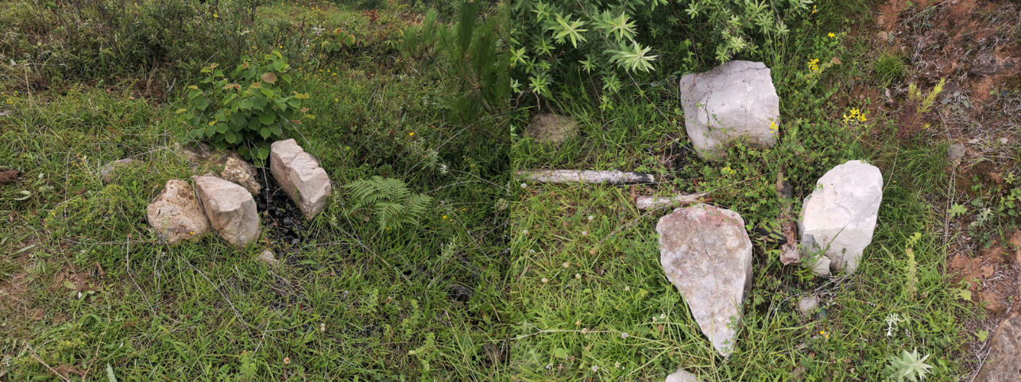

SM Figure 2. Nuosu grave sites (*chi’he*) where the bodies of the dead were burned.

SM video 1 (funeral march): <https://youtu.be/VXQsaJqUL1o>

SM video 2 (sheep shoulder blade divination): <https://www.youtube.com/watch?v=N5s9A5hauog>

SM video 3 (*nuciguo*): <https://www.youtube.com/watch?v=HHLD2MmzTVg>

SM video 4 (twig divination): <https://youtu.be/X89vbGtu0EU>

SM video 5 (twig divination): <https://youtu.be/tyBu1Dvt7S4>

SM video 6 (exorcism ritual): <https://youtu.be/4etDdFxo4nc>

SM video 7 (exorcism ritual): <https://youtu.be/WFWztOy4oS0>

SM video 8 (exorcism ritual): <https://youtu.be/VlWhnrKLSfQ>

SM video 9 (egg divination): <https://youtu.be/j6TueG9AA4k>

SM video 10 (egg divination): <https://youtu.be/UYczLXtNQ5k>

SM video 11 (egg divination): <https://youtu.be/P1bLOcuFr3s>

SM video 12 (egg divination): <https://youtu.be/UyW5gYIz4Ss>

SM video 13 (egg divination): <https://youtu.be/x69IbyLRGHE>

SM video 14 (egg divination): <https://youtu.be/VTe4tMxsuic>

SM video 15 (egg divination): <https://youtu.be/j6TueG9AA4k>

1. Du (2016) documented a few actual cases of Yi mixin rituals with many details, but it is likely some of the rituals were “staged” and the specialists (bimo/suni) wished to present an ideal ritual for the outside audience (journalists, etc.). For example, contrary to what Du (2016) suggests where individuals turn off all their cell phones and electronic devices and listen to bimo’s chanting with much respect and even piety during a xiaobu ritual, all the xiaobu rituals that I’ve participated in the field are extremely casual, with adults chatting and checking their smart phones, children running and playing, even the bimo himself may answer a phone call in the middle of his chanting and then resume like nothing had happened. Very few people were paying attention with to the bimo. In fact, most of the time the bimo looks more like a hired entertainer during a family party. See (Zheng, 2003) for a more realistic description of a ritual.